**Project 4 Task 1 Writeup**

**Student Information**

* **Jung Ho Park, junghop**

**1. API Selection**

I have selected the Open Library API for my project. Open Library provides a free and open API that allows developers to search for books, authors, and other literary information.

* **API Name:** Open Library API
* **API Documentation URL:** https://openlibrary.org/developers/api

**2. Application Description**

My mobile application will allow users to search for books by title, author, or keywords. The app will display matching books with their details including title, author, and publication year. Users can perform multiple searches without restarting the app, making it easy to explore different books and authors.

**3. API Implementation**

I created a Java application that connects to the Open Library API and retrieves book information. The application:

* Accepts a search query
* Makes an HTTP request to the Open Library search endpoint
* Parses the JSON response
* Extracts and displays relevant book information

**Screenshot of API Console Output**

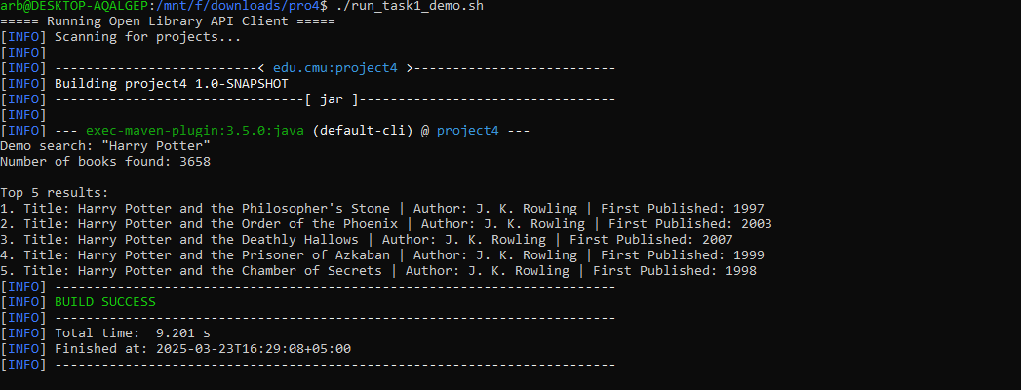`

**4. MongoDB Atlas Implementation**

I successfully set up a MongoDB Atlas database in the cloud and created a Java application that:

* Prompts the user to enter text
* Stores the entered text in a MongoDB coeellection
* Retrieves all documents from the collection
* Displays the stored text values from all documents

**Screenshot of MongoDB Console Output**

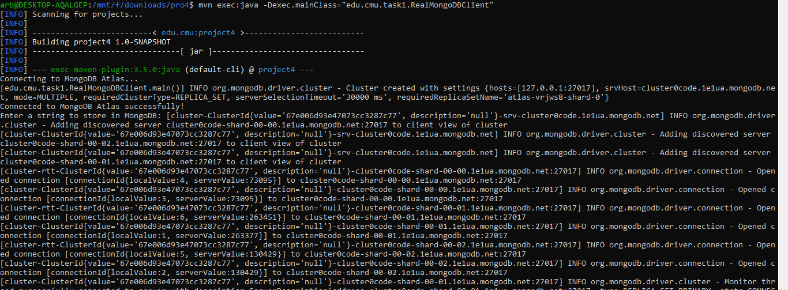

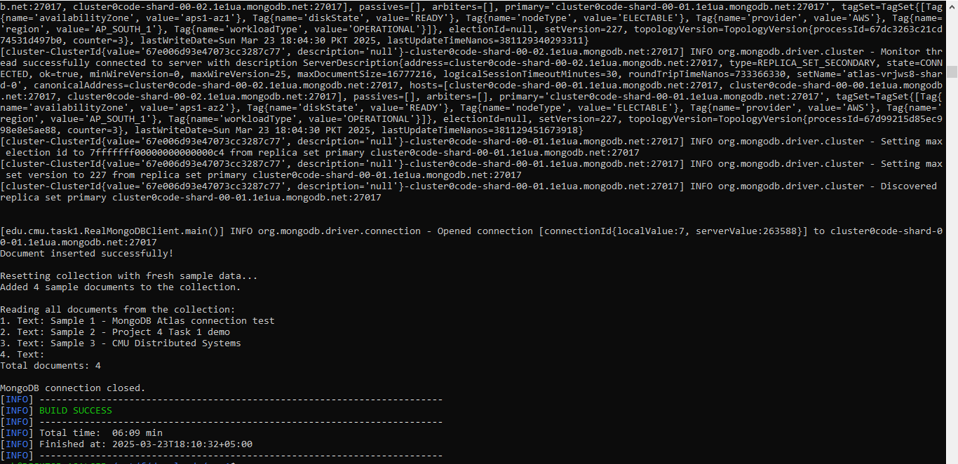**5. Technology Stack**

For my final project implementation, I will use:

* **Frontend:** Android native app with Java
* **Backend:** Java servlets deployed to GitHub Codespaces
* **Database:** MongoDB Atlas
* **External API:** Open Library API
* **Data Format:** JSON

This combination will allow me to create a responsive mobile application that leverages cloud resources for data processing and storage while providing valuable book information to users.